**Collections**

**Instructions:**

1. Create com.accenture.tcf.codingassessment.collection package
2. Create each classes based on the UML diagram.

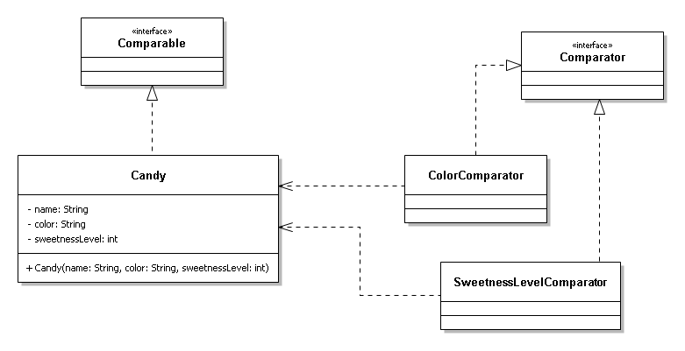

1. Create a MainClass.java and create 5 instance of Candy Object.

Candy candy1 = new Candy(“Lollipop”, “Red”,5);

..

..

Candy candy5 = new Candy(“Max”, “Green”,2);

1. Sort the candy instances by name, color, sweetness level

Sample Output:

-------------------------------------------------

Sorted By Name :

Name Color Sweetness Level

Lollipop Red 5

..

..

Max Green 2

-------------------------------------------------

Sorted By Color :

Name Color Sweetness Level

Max Green 2

..

..

Lollipop Red 5

-------------------------------------------------

Sorted By Sweetness Level:

Name Color Sweetness Level

Max Green 2

..

..

Lollipop Red 5

-------------------------------------------------